The Cost of Net Zero Electrification of the U.S.A.
December 20, 2021
By: Ken Gregory, P.Eng.

Executive Summary
Many governments have made promises to reduce greenhouse gas emissions by replacing fossil fuels with solar and wind generated electricity and to electrify the economy. A report by Thomas Tanton estimates a capital cost of US$36.4 trillion for the U.S.A. economy. This study identifies several errors in the Tanton report and provides new capital cost estimates using 2019 and 2020 hourly electricity generation data rather than using annual average conditions as was done in the Tanton report. This study finds that the battery costs for replacing all current fossil fuel fired electricity with wind and solar generated electricity, using 2020 electricity data, is 109 times that estimated by the Tanton report. The total capital cost of electrification is herein estimated, using 2020 data, at US$433 trillion, or 20 times the U.S.A. 2019 gross domestic product. Overbuilding the solar plus wind capacity by 21% reduces overall costs by 18% by reducing battery storage costs. Allowing fossil fuels with carbon capture and storage to provide 50% of the electricity demand dramatically reduces the total costs from US$433 trillion to US$24 trillion, which is a reduction of 94.6%. Battery storage costs are highly dependent on the year’s weather and the seasonal shape of electricity demand.

Introduction
The Canadian government has set a target to reduce greenhouse gas emissions from fossil fuel use and cement manufacturing to net zero by 2050. Some believe we could achieved this by replacing most fossil fuel use with non-emitting energy sources and sequestering carbon dioxide (CO₂) emissions from the remaining fossil fuel use by carbon capture and storage (CCS).
This article provides an estimate of capital costs to achieve net zero emissions in the U.S.A. and Canada based largely on an analysis by Thomas Tanton in his report “Cost of Electrification: A State-by-State Analysis and Results”. Estimating the increased operating costs is beyond the scope of this study.
Mr. Tanton is President of T2 & Associates, a firm providing consulting services to the energy and technology industries. T2 & Associates are active primarily in the area of renewable energy and interconnected infrastructures. Mr. Tanton is also Director of Science and Technology at Energy and Environment Legal Institute. Mr. Tanton has provided expert testimony regarding energy technology to the House Energy and Commerce Committee and several state legislatures. He has 45 years of direct and responsible experience in energy technology and legislative interface.
The executive summary of the Tanton report states for the U.S.A. “Electrifying the entire nation, with a goal of eliminating the direct consumption of fuel would cost between US$18 trillion and US$29 trillion in first costs.” The lower cost assumes that dispatchable fossil fuels are used to generate electricity with carbon capture and storage to electrify the U.S.A. economy. The higher cost assumes only solar and wind are used to replace other power sources for electricity generation with batteries for backup energy to handle the solar and wind intermittency.
The Tanton report says that the costs were based on the average monthly demand for natural gas, ignoring the seasonal variations. The demand in January in the residential sector is 2.5 times higher than the average monthly demand for natural gas. This must be taken into account to protect public health and safety. The report says “This would add approximately $7 trillion to our estimates for a total of over $36 trillion.”
A news release issued by the Energy and Environmental Legal Institute says “The bottom line is that electrification is not a cost-effective means of reducing carbon emissions from commercial or residential buildings nor the transportation sector.”

The Tanton Report Review
Tanton provided an Excel file that allowed me to review the assumptions and calculations of the cost estimate. This review revealed several deficiencies in the report. The Excel file calculates costs for:
- converting the existing electricity generation to renewable solar & wind energy,
- replacing natural gas for residential and commercial building heating and cooling to solar & wind energy,
- converting residential and commercial building to electric heating,
- purchasing electric vehicles rather than gasoline and diesel vehicles,
- replacing gasoline and diesel with solar & wind energy for electric vehicles.
The total cost of these items as shown in the Excel file and appendix A1 of the Tanton report is US$29.2 trillion. This value doesn’t include costs of electrifying aviation and shipping or the $7 trillion cost to account for seasonal variations of heating demand.
Here are the problems I found with the analysis:
- All of the existing non-solar and non-wind annual electricity generation is replaced with new solar and wind (S+W) electricity. To reduce greenhouse gas (GHG) emissions, non-GHG emitting sources such as nuclear, hydro, geothermal and waste power sources do not need to be replaced. Generation based on biomass also doesn’t need to be replaced. By accepting these sources, the fraction of generation that should be replaced can be reduced from 90.3% to 62.0%, which is the fossil fuel portion for 2019, or to 59.9%, which is the fossil fuel portion for 2020.
- The S+W average capacity factor of 33.3% was used (by multiplying the average output by 3). The 2019 actual capacity factors were 32.6% for wind and 20.1% for solar. The combined capacity factor was 28.0% in 2019, dropping to 27.6% in 2020. The capacity factor used was too high.
- Tanton uses sales of electricity which doesn’t include energy losses through the transmission system. The net generation to replace fossil fuels should include transmission losses, which were 212,500 GWh in 2019.
- The transmission costs are based on the average power of all generation rather than on the new wind and solar energy being added.
- The battery storage costs are far too low and do not account for seasonal, daily and hourly changes of wind and solar output.
- The costs for replacing natural gas used for heating and cooling include volumes of natural gas used for generating electricity. This volume is double counted as it is accounted for in the existing electricity generation calculation.
- The natural gas heating efficiency for space heating, estimated at 90%, was not considered.
- The report decreases the incremental cost of electric vehicles over gasoline and diesel vehicles by the amount of government subsidies. These subsidies are costs to taxpayers, who are also the electricity ratepayers. The full cost before subsidies should be used.
- Costs of offsetting emissions from fuels by carbon capture and storage used for aviation and marine vessels or electrifying them are excluded.
- Costs for converting off-road vehicles (e.g., tractors) to electricity are excluded.
A US Energy Information Agency (EIA) report “Capital Cost and Performance Characteristic Estimates for Utility Scale Electric Power Generating Technologies” published in 2020 estimates that a 200 MWh battery energy storage system has a capital cost of US$65.9 million or US$347 per kWh of energy storage capacity. The Tantan report estimates the battery storage costs are 1850 $/kWyr, or 0.21 $/kWh of average S+W energy production. This buys storage capacity equal to 5.3 hours, or 0.22 days of average electricity generation. This analysis will show the actual storage costs are $29.18 /kWh of average electricity production for 2020. This assumes that new S+W electricity exactly replaces fossil fuel fired electricity generation with batteries providing backup energy.
In summary the major error of the Tanton report is that battery storage costs for the case where fossil fuels do not provide electrical energy is far too low, which is partially compensated by converting too much natural gas fired electrical energy to solar and wind energy. The net effect of the identified errors is that he under-estimated the costs of "decarbonizing" the US electrical energy system in the case without using fossil fuels.

New Costs Analysis
I created a spreadsheet to calculate the battery storage requirement assuming that the hourly fossil fuel fired electricity generation is all or partially replaced by S+W energy. I assumed that the battery efficiency is 90%, meaning that charging the battery with 100 MWh and discharging 90 MWh leaves the battery storage unchanged.
The spreadsheet calculates hourly imbalance between the customer demand for electricity and the supply of S+W and fossil fuel fired electricity. The battery charge is adjusted from the imbalance to account for the battery efficiency. In the cases where new S+W capacity replaces only a portion of the fossil fuel fired electricity, the maximum fossil fuel fired generation is reduced by 15% to account for the extra fuel required to capture the CO₂ from the exhaust gas. The S+W electricity production profile was increased by a “solar+wind multiplier” factor to provide the same annual electricity from fossil fuels that is being replaced. Iterative solving was performed to ensure the hourly battery charges and discharges sum to zero for the annual total and the fraction of fossil fuel fired electricity equal the assumed value for each case. See Appendix 1 for a detailed description of this calculation.
I created 7 cases; each case has results utilizing the 2019 and 2020 S+W production profiles. Four cases assume that 0%, 50%, 40% and 60% of actual 2019 or 2020 fossil fueled electricity generation would be used and the other portion would be replaced with S+W electricity to supply current electricity demand. The S+W generation capacities are set so that the annual electricity production for current demand equals the current annual S+W electricity generation plus the fossil fueled electric energy replaced.
Three cases assume that S+W generation capacities are higher than required to replace the fossil fuel fired electrical energy but the S+W power output is limited to a maximum value. The overcapacity of S+W generation increases its cost but reduces the variability of the used generation and reduces battery costs. Potential S+W energy is lost during windy days when the potential S+W power is greater than the set maximum.
The electricity requirements for new demand for replacing directly used fossil fuels for heating, cooling and transportation were calculated in each case using the same fraction of fossil fuels for electricity generation and fraction of power losses as the current demand.
The aviation and shipping costs are the cost of carbon capture and storage (CCS) for the fossil fuels used. Airplanes and ships are assumed to continue to use fossil fuels in all cases.
The cases with fossil fuel fired electricity include costs for carbon capture and storage (CCS) and reduce the amount of solar and wind power that would be required to meet net zero emissions.
The costs of CCS are based on estimates published by the US EIA in 2020. The average incremental cost of CCS for coal and natural gas fired generating plants was used, which was taken to be $1800/kW. Additional costs for transport, storage and monitoring facilities were estimated at $283/kW. This achieves 90% capture and storage. The cost for capturing the remaining 10% of carbon dioxide production was estimated at $500/kW, giving a total cost of $2,583/kW of net plant capacity. This analysis does not consider the higher operating costs associated with CCS.
All costs in this study, like those in the Tanton report, assume the electrification is implemented “overnight” which means ignoring the time duration of construction. This simplifies calculations by avoiding forecasting interest charges during construction and future inflation. All costs are in US 2019 dollars.
Table 1 below summarizes the seven cases.
Case | Fossil Fuel Share | S+W capacity is increased, power is limited.
1 | 0% | No
2 | 0% | Yes
3 | 50% | No
4 | 50% | Yes
5 | 40% | No
6 | 40% | Yes
7 | 60% | No
Table 1
Appendix 2 shows cost parameters used in this analysis. Many parameters were taken from the Tanton Report and were not independently verified by me.
Figure 1 shows the actual hourly net S+W net electricity generation for the years 2019 and 2020. The graph shows the electricity generation is extremely variable. The use of S+W generation from 48 contiguous states implicitly assumes that there is sufficient unconstrained transmission capacity to share any excess or to cover any shortfall among the states. Transmission costs may be higher than estimated here to the extent that this assumption is not satisfied.
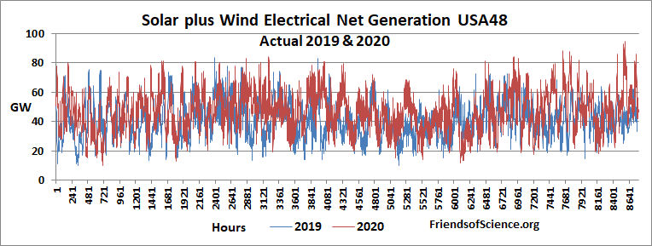
Figure 1

Case 1
This case is equivalent to the Tanton report case of replacing non-renewables with S+W energy. I assume that the S+W energy added equals the fossil fuel generated electrical energy it replaces and battery storage would be used to provide (or store) electrical energy when wind and solar energy generation are less than (or greater than) the total hourly demand.
Figure 2 shows the hourly S+W energy that would be required if the fossil fuel fired electric energy was replaced with S+W energy with battery backup using the 2020 S+W production profile.
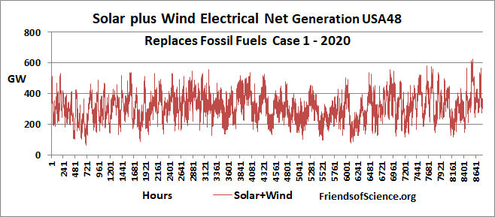
Figure 2
Figure 3 shows the change in battery energy storage required to backup the S+W energy to avoid energy shortfalls utilizing the 2019 and 2020 S+W production profiles. The S+W energy produced in the case over each year is equal to the fossil fuels fired electrical energy plus the S+W energy actually produced in the USA during the year.
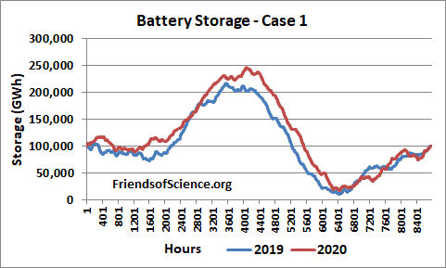
Figure 3

The table case 1 shows the existing demand (ED) (including battery losses), days of battery storage required, battery losses, the battery storage used and the solar+wind multiplier. The battery storage is the maximum energy storage level less the minimum energy storage level of each year. The days of storage is 365 days times the required storage percentage of the total demand. The table case 1 also shows a cost breakdown, the total cost and the total storage costs.
Case 1 | Solar and wind replaces fossil fuels
Year | 2019 | 2020
Existing demand ED (TWh) | 3026 | 2937
Days of storage | 26.9 | 30.7
Battery losses for ED (TWh) | 41.4 | 41.5
Battery storage for ED (TWh) | 206.0 | 228.3
Solar+wind multiplier | 7.806 | 6.602
Storage cost ED (US$ B) | 77,424 | 85,689
Total cost of ED (US$ B) | 79,379 | 87,552
Conversion from nat. gas (US$ B) | 119,922 | 136,313
Convert buildings (US$ B) | 9,479 | 9,479
Electric vehicle costs (US$ B) | 6,644 | 6,644
Vehicle electricity (US$ B) | 169,906 | 193,129
Aviation and shipping CCS (US$ B) | 191 | 191
Total cost (US$ B) | 385,550 | 433,308
Total storage cost (SU$ B) | 358,933 | 406,697

The cost comparison of the Tanton report and Case 1 in terms of cost per S+W energy production and days of battery storage is given in table 2.
Without fossil fuels | $/kWh | Days
Tanton | 0.21 | 0.22
Case 1, 2019 | 25.59 | 26.9
Case 1, 2020 | 29.18 | 30.7
Table 2
If fossil fuel fired electrical power is not available to back up the highly variable S+W energy and only batteries can be used as back up, the battery backup becomes extremely expensive. Considering only the current electricity demand, the battery storage costs using the 2020 production profile is US$85.7 trillion, or 109 times the US$ 0.786 trillion battery storage costs estimated in the Tanton report. The total storage cost using the 2020 S+W production profile is 93.9% of the total cost of electrification. The total storage cost of US$406.7 trillion is 88 times the total storage costs estimated in the Tanton report.
The total cost to electrify the USA is US$386 trillion with the 2019 profile and US$433 trillion with the 2020 profile. To put these costs in perspective, the USA nominal gross domestic product (GDP) in 2019 was US$21.43 trillion. The 2020 total cost of electrifying the US economy is equivalent to over 20 times the US 2019 GDP. Case 1 is totally impossible as the capital cost of US$433 trillion is far too expensive.

Case 2
Case 2 | S+W capacity is increased, power is limited
Year | 2019 | 2020
Existing demand ED (TWh) | 2973 | 2883
Solar+wind multiplier | 9.00 | 8.00
Max S+W dispatched | 47.1% | 44.2%
Days of storage | 21.78 | 24.94
Battery storage for ED (TWh) | 166.2 | 184.9
Total cost of ED (US$ B) | 63,829 | 70,610
Total cost (US$ B) | 316,583 | 356,662
Total Storage cost (SU$ B) | 288,568 | 328,056
In Case 2 the Solar+Wind Multiplier is increased with the goal of reducing storage requirements. This creates excess S+W capacity; consequently the S+W output must be limited to a fraction of its capacity. This wastes generating capacity but reduces battery storage requirements as shown in table case 2.

The 2019 S+W multiplier was increased from 7.806 in case 1 to 9.00 in case 2. This increases S+W capacity installation and transmission costs for the existing demand from US$1.96 trillion to US$2.22 trillion. However, the maximum S+W dispatched to satisfy demand is reduced from 100% to 47.1% of generation capacity. The total battery storage costs with the 2019 production profile drops from US$359 trillion in case 1 to US$289 trillion in case 2, a drop of US$70 trillion.
Figure 4 shows the hourly S+W energy required for case 2 using the 2020 S+W production profile.
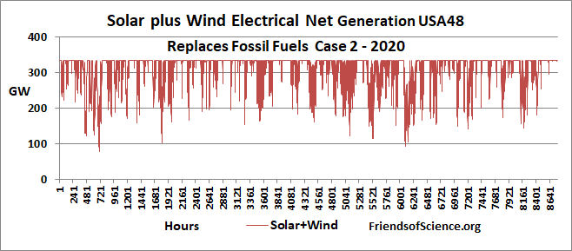
Figure 4
The total battery costs with the 2020 S+W profile declines from case 1 to case 2 by US$78.6 trillion. Figure 5 shows the resulting battery storage requirements.
The total cost with the 2020 profile is reduced due to lower storage costs by 17.7% despite higher S+W capacity of 21.2% compared to case 1.
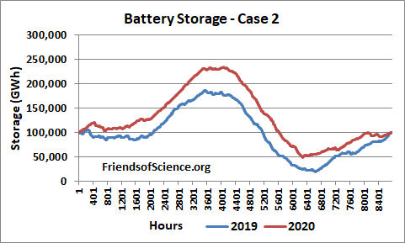
Figure 5

Case 3
In Case 3 the fossil fuel fired generation capacity in maintained at current levels but it provides 50% and S+W provides 50% of total demand. The S+W capacity is reduced compared to case 1 and the S+W energy output isn’t limited as shown in table case 3.
Case 3 | Fossil Fuels provide 50%, S+W isn’t limited
Year | 2019 | 2020
Existing demand ED (TWh) | 2940 | 2850
Solar+wind Multiplier | 3.845 | 3.250
Max S+W dispatched | 100% | 100%
Days of storage | 0.13 | 0.02
Total cost of ED (US$ B) | 1,583 | 1,356
Total cost (US$ B) | 24,279 | 23,490
Total storage cost (SU$ B) | 879 | 95
Total CCS costs ($US B) | 2,220 | 2,206

The existing demand row of the table is now the electricity generation of the sum of the fossil fuels and the S+W electricity, each providing 50% of the existing demand.
By allowing fossil fuels to provide 50% of electricity demand with S+W, costs of electrifying drop dramatically. The maximum capacity of fossil fuel fired electricity with the 2020 production profile is maintained at the actual capacity of 486 GW, but it only provides electricity equal to an average power of 307.2 GW. Cost of CCS is US$2.2 trillion and storage costs are nominal. The total cost is US$23.5 trillion, which is only 5.4% of the case 1 total cost.
Figure 6 shows the fossil fuel fired and S+W electrical generation with the 2020 production profiles.
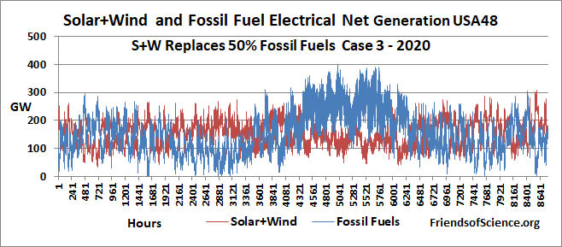
Figure 6
During much of the year the fossil fuel fired electricity production is far below capacity, even going to zero a times, but for months fossil fuels provide most of the electrical demand. The fact that fossil fuel generation is vastly less expensive that battery storage is what drives the cost down.

Case 4
In case 4, fossil fuel provides 50% of total existing demand and the S+W capacity is increased from case 3 values but the S+W power generation is limited.
Case 4 | Fossil Fuels provide 50%, S+W is limited
Year | 2019 | 2020
Existing demand ED (TWh) | 2940 | 2850
Solar+wind Multiplier | 4.190 | 3.445
Max S+W dispatched | 53.01% | 57.49%
Days of storage | 0.0 | 0.0
Total cost of ED (US$ B) | 1,474 | 1,386
Total cost (US$ B) | 23,816 | 23,673
Total storage cost (SU$ B) | 1 | 0
Total CCS costs ($US B) | 2,220 | 2,206

Figure 7 shows the fossil fuel fired and S+W electrical generation with the 2020 production profiles. The S+W capacity is increased by 6% compared to case 3 and the maximum S+W dispatched to the grid is limited to 57.49% of its capacity with the 2020 production profiles.
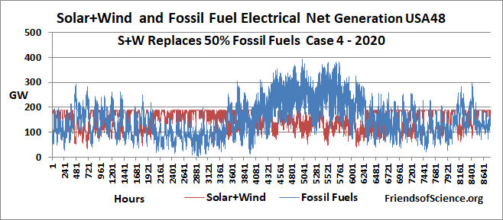
Figure 7
The total cost of the case decreases by US$0.46 trillion with the 2019 production profile but increases US$0.18 trillion with the 2020 production profile. In both production profiles, the S+W installation cost increased due to higher S+W capacities and the transmission costs decreased dues to deceased battery losses in case 4 from case 3.

Cases 5, 6 and 7
In cases 5 and 6 the fossil fuel share of electricity generation decreases to only 40% and S+W contributes 60%. In case 7 the fossil fuel share of electricity generation is 60%. The following two tables give the parameters and results for the 2020 and 2019 production profiles.
Year 2020 | Case 5 | Case 6 | Case 7
Fossil Fuels % of Electricity | 40% | 40% | 60%
Existing demand ED (TWh) | 2851 | 2851 | 2850
Solar+wind Multiplier | 3.902 | 4.000 | 2.600
Max S+W dispatched | 100% | 64.74% | 100%
Days of storage | 0.81 | 0.30 | 0.01
Total cost of ED (US$ B) | 2,755 | 1,942 | 1,249
Total cost (US$ B) | 30,325 | 26,454 | 22,845
Total storage cost (SU$ B) | 6,317 | 2,306 | 60
Total CCS costs ($US B) | 1,803 | 1,802 | 2,609

Year 2019 | Case 5 | Case 6 | Case 7
Fossil Fuels % of Electricity | 40% | 40% | 60%
Existing demand ED (TWh) | 2941 | 2940 | 2940
Solar+wind Multiplier | 4.616 | 4.700 | 3.076
Max S+W dispatched | 100% | 67.00% | 100%
Days of storage | 1.31 | 0.62 | 0.01
Total cost (US$ B) | 34,318 | 28,944 | 22,859

The tables show that the 2020 production profiles give lower total costs than the 2019 production profiles. This is because the 2020 profile has lower total electricity demand and, for cases 5 and 6, lower storage requirements. The actual 2020 electricity demand was materially affected by the COVID pandemic. Case 6 has lower costs than case 5 because the lower battery storage requirements more than offset the higher S+W capacity costs. Case 7 has the lowest total cost of all cases for both production profiles because it uses the highest fraction of fossil fuels which are dispatchable and not weather dependent.

Summary of Cases
Table 3 summarizes the total costs of the seven cases.
Total cost of electrification |  |  | US$ trillion | US$ trillion
Case | Fossil Fuel % | S+W increase capacity | 2019 | 2020
1 | 0% | No | 385.5 | 433.3
2 | 0% | Yes | 316.6 | 356.7
3 | 50% | No | 24.3 | 23.5
4 | 50% | Yes | 23.8 | 23.7
5 | 40% | No | 34.3 | 30.3
6 | 40% | Yes | 28.9 | 26.5
7 | 60% | No | 22.9 | 22.8
Table 3

Conclusions and Discussion
I reviewed the Tanton report which estimated the capital costs of the electrification of the USA without the use of fossil fuels. I listed several issues with the report. The most important problem was that without fossil fuels providing electricity back up for intermittent and variable wind and solar energy, battery storage back up is extremely expensive. The calculations show that total battery storage costs for existing electricity demand is 109 times the Tanton estimate and the total battery costs for existing and new electricity demand is 88 times the Tanton estimate when using the 2020 production profile. The total cost of electrification without fossil fuels is estimated at US$386 trillion and US$433 trillion using the 2019 and 2020 energy production profiles, respectively. Since the weather and consequently the battery storage costs are so variable, the actual battery storage costs would be higher than estimated here to provide a reasonable amount of contingency battery reserve. The cost of US$433 trillion is equivalent to over 20 times the US 2019 GDP. It would cost every adult (18 year and over) a total of US$1.7 million!
Total electrification capital costs can be reduced by overbuilding solar and wind capacity. The total costs with the 2020 production profile are reduced by 18% by overbuilding the solar plus wind capacity by 21%. The tradeoff is that battery storage costs are significantly reduced.
When fossil fuels provide 50% of the total electricity demand, it is also providing backup services for the S+W electricity, so battery cost are mostly eliminated and electrification capital costs are reduced to about US$24 trillion. Capital costs can be further reduced to about US$23 trillion by allowing fossil fuels to provide 60% of the total electricity demand.
Regardless of the fraction of electricity provided by fossil fuels, these costs assume that the existing generating capacity be maintained at current levels. The capacity factor for fossil fuels when they provide 50% of electricity demand is 63%, which would push up electricity backup operating costs.
Note that the estimates for CCS assume that coal or combined cycle natural gas fired power plants are used, but these high efficiency power plants are generally unsuitable for backing up S+W generation because the rapid swings necessary to match total generation to net demand (the demand left over after subtracting that supplied by extremely variable W+S generation) puts a great deal of thermal strain on the plant components, thereby increasing maintenance costs. It also reduces the thermal plants’ fuel efficiency. Thermal backup power is more often provided by smaller, more flexible simple-cycle gas turbines that have lower capital costs but also lower fuel efficiencies. Combined cycle gas plants typically are 55% efficient and simple-cycle gas plants are 35% efficient. Therefore simple cycle natural gas plant consumes 55/35 = 157% of the fuel that a combined cycle natural gas plant does for the same electricity output. The simple cycle gas plant will emit 57% more CO₂ than a combined cycle gas plant for the same electricity output. This suggests that the capital costs estimated herein for CCS may be low and the operating costs for backup power will be much higher than they are currently.
The experience in the European Union shows that increasing solar and wind capacity leads to higher electricity prices. The residential electricity costs of the 28 European Union countries varied from 9.97 to 30.88 Euro cents in 2019. The costs generally increase linearly with increasing solar plus wind capacity per capita. This implies that the solar plus wind electricity costs are 5.7 times that from other sources when backup costs are included as shown here.

Why Incur Ruinous Capital and Operating Costs for Net Zero?
There is no scientific or economic justification to incur any capital or operating cost increases for net zero because CO₂ emissions are net beneficial to people and the environment. The paper “Social Cost (Benefit) of Carbon Dioxide from FUND with Corrected Temperatures, Energy and CO₂ Fertilization” shows that the social net benefits of CO₂ emissions as calculated by the FUND integrated assessment model are US$6/tCO₂ using a 5% discount rate and US$12/tCO₂ using a 3% discount rate. The benefit of emissions and warming on agriculture from 2000 to 2100 is 95 times the cost of severe storms and sea level rise combined. Other values of high social costs come from faulty computer models that fail to include the benefits of both warming and CO₂ fertilization, use extremely high emissions projections, assume that the climate is far more sensitive to increases in atmospheric CO₂ than real-world data suggests is the case, fail to account for adaptation and exaggerate damages. CO₂ is plant food and increasing CO₂ concentrations are greening the Earth and increasing crop yields. The net benefits of CO₂ emissions imply that fossil fuel use should be subsidized to account for the great net benefits of CO₂ emission; not taxed.

Appendix 1 – Calculation of Battery Storage
In the cases where no fossil fuel fired electricity is used, an “imbalance” between the actual hourly “target demand” and the modeled hourly S+W generation is calculated. Since I assume the existing nuclear, hydro and biomass electricity generation will continue, the hourly target demand is equal to the hourly fossil fuel fired electrical generation plus the existing hourly S+W generation. The modeled S+W generation is the actual S+W generation multiplied by a factor which I called the “solar+wind multiplier”. The hourly imbalance is the difference between the target demand and the modeled S+W generation required to replace the current fossil fuel fired electricity generation.
The hourly change in battery storage is the hourly imbalance adjusted to account for the 10% loss of electricity over a charge and discharge cycle. When the hourly imbalance is positive the battery charge increase is 95% of the imbalance. When the hourly imbalance is negative the battery discharge is 0.95/.90 = 1.0556 of the imbalance. The solar+wind multiplier is set so that the year’s initial and final storage levels are equal. This implies that that the new S+W energy added is in the same proportion as is currently generated, which for 2020, was 28% solar and 72% wind energy. Together, S+W provided 11.6% of USA 2020 electricity generation.
In the cases with fossil fuels providing a portion of the electricity generation, the fossil fuel hourly usage is limited by the current fossil fuel fired generation capacity less 15% to account for the power consumed at source to capture the CO₂ from the exhaust gas. The hourly fossil fuel fired electricity generation is the lesser of the limit described above and the difference between the target demand and the S+W modeled generation (i.e. the actual 2019 or 2020 S+W generation times the solar+wind multiplier) plus or minus extra fossil fuel fired generation. This extra amount is required to allow flexibility to achieve an annual balance of charge and discharge of the storage battery. For a given fossil fuel percent electricity generation, an iterative solving technique is required to adjust the extra fossil fuel electrical energy and the solar+wind multiplier to achieve an annual battery balance.
The hourly electricity generation data by source for the 48 contiguous USA states was obtained from the EIA to determine the battery storage requirements and battery losses. The USA total annual electricity data by energy source for fossil fuels and solar was obtained from the EIA, table 3.1.A. Net Generation by Energy Source. The USA total annual wind electricity was obtained from the EIA, table 3.1.B. Net Generation from Renewable Sources.

Appendix 2 – Cost parameters
Cost parameters and source
Cost Item | Parameter | Source
Solar and Wind direct costs | US$1694/kW of capacity | Tanton Report
Transmission cost new capacity | US$65.3/MWh | Tanton Report
Natural gas used excl. electricity | 11,003 bcf | Energy Info Agency
Natural gas heating efficiency | 90% | Energy.gov
Non-electric households | 78.8 million | Tanton Report
Household conversion cost | US$ 10,000 | Tanton Report
Commercial conversion cost | US$100/square foot | Tanton Report
EV on road fuel electricity equiv. | 5965 TWh | Tanton Report
EV on road fuel electricity equiv. | 485 TWh | Tanton Report
Automobiles | 112.96 million | Tanton Report
Trucks | 146.18 million | Tanton Report
Buses | 0.98 million | Tanton Report
Motorcycles | 8.68 million | Tanton Report
Tractors | 4.2 million | Tractors and …
Automobiles incremental. EV cost | US$13/unit | Tanton + subsidies
Trucks incremental. EV cost | US$34/unit | Tanton + subsidies
Buses incremental. EV cost | US$42/unit | Tanton + subsidies
Motorcycles incremental EV cost | US$2.5/unit | Tanton + subsidies
Tractors incremental. EV cost | US$34/unit | Tanton + subsidies
Aviation fuel | 18,746 million US gallon | US Dept. Trans.
Aviation fuel emissions | 9.57 kg CO2/US gallon | GHGprotocol.org
Shipping fuel | 405,000 bbl/d | Oak Ridge NL
Shipping energy | 907.9 trillion btu | Oak Ridge NL
Shipping emissions | 2.7 kg CO2/Litre | Nat. Res. Can
US electricity emissions | 0.386 kg CO2/kWh | Energy Info Agency

Thomas Tanton, Cost of Electrification: A State-by-State Analysis and Results, October 2020 https://eelegal.org/wp-content/uploads/2020/09/LCOE2-for-posting-9.17.2020.pdf
https://eelegal.org/wp-content/uploads/2020/09/cost-of-electrification-tool-final-2.25.2020-with-intro.xlsx
Item 3 of appendix B of the Tanton report says “Determine kW of solar and wind at 30% capacity factor by multiplying a.c.[average capacity] by 3.” For a 30% capacity factor, the a.c. must be multiplied by 1/0.3 or 3.3333, not by 3.
GWh = Gigawatt-hours = 1000 Megawatt-hours = 1000 MWh.
Capital Cost and Performance Characteristic Estimates for Utility Scale Electric Power Generating Technologies, page 29 https://www.eia.gov/analysis/studies/powerplants/capitalcost/pdf/capital_cost_AEO2020.pdf
Tanton uses battery costs of 1850 $/kW where kW is the power demand averaged over a year, meaning a kilowatt-year = kWyr = 8760 kWh.
http://kbgregory.com/Climate/CND-Reserves-Tanton-Review-Net-Zero1.xlsx
The Tesla Powerwall round trip efficiency is 90%. Tesla, Powerwall, https://www.tesla.com/sites/default/files/pdfs/powerwall/Powerwall%202_AC_Datasheet_en_northamerica.pdf
Capital Cost and Performance Characteristic Estimates for Utility Scale Electric Power Generating Technologies, https://www.eia.gov/analysis/studies/powerplants/capitalcost/pdf/capital_cost_AEO2020.pdf
TWh = Terrawatt-hours = 1000 GWh. “Demand” means electricity energy requirements.
B = billion.
Ken Gregory, European Wind Plus Solar Cost 6 Times Other Electrical Sources, 2020, https://friendsofscience.org/index.php?id=2550
Ken Gregory, Social Cost (Benefit) of Carbon Dioxide from FUND with Corrected Temperatures, Energy and CO₂ Fertilization, 2021, https://friendsofscience.org/index.php?id=2579
See Climate Science, “CO2 and Plant Growth” on the Friends of Science website for further information at; https://friendsofscience.org/index.php?id=223
EIA, https://www.eia.gov/opendata/qb.php?category=3390105
EIA, https://www.eia.gov/electricity/annual/html/epa_03_01_b.html

